https://www.youtube.com/watch?v=npAlosGwXdw

for mac

mvnw quarkus:add-extension -Dextensions="resteasy-jsonb"

mvnw quarkus:add-extension -Dextensions="panache"// error multiple extension

for windows or linux

setting up and configuring hibernate ORM with Panache first

at https://quarkus.io/guides/hibernate-orm#hibernate-configuration-properties

with postgresql

mvnw quarkus:add-extension -Dextension="jdbc-postgresql, hibernate-orm-panache, hibernate-validator, resteasy-jsonb"

https://www.youtube.com/watch?v=KrVoOBBdguk

mvnw compile quarkus:dev

mvnw quarkus:dev:

if you didn’t connect to database, initial the value manually in the code

define entity in the class entity

operation in compteservice

follow tutorial Daniel oh for more than one entity or

quarkus.datasource.driver=org.postgresql.Driver

or  
quarkus.datasource.db-kind = postgresql

<https://www.youtube.com/watch?v=_vhskxEihz4> for hibernate one to many

import.sql see on <https://quarkus.io/guides/hibernate-search-orm-elasticsearch>

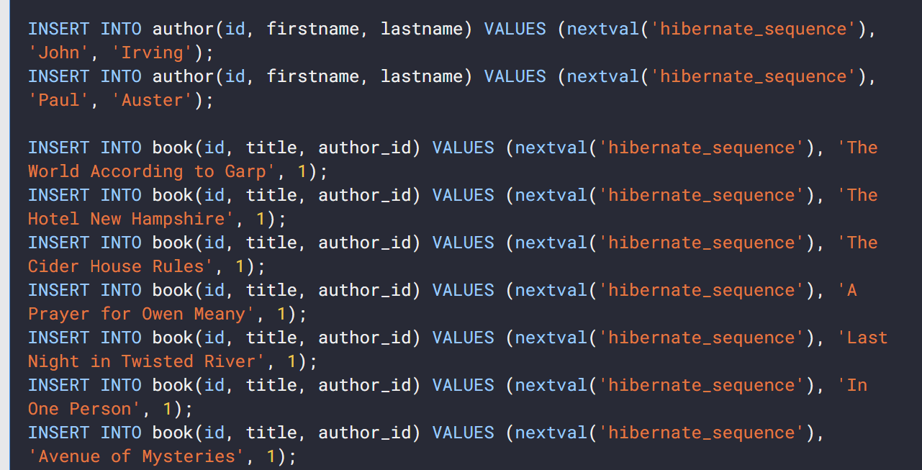

With id to another coloumn